Week 1 task(Nov 8 2025):
1)Create a library database with tables: Books, Authors, Borrowers, Loans.
Write SQL queries to:
List all books borrowed by a specific borrower.
Find authors whose books are borrowed more than 5 times.
Count the number of books each borrower has borrowed.
Ans:
1)Create a library database with tables: Books, Authors, Borrowers, Loans
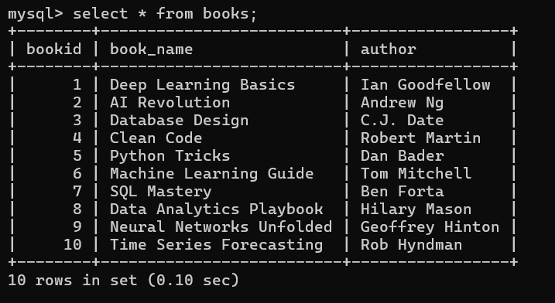
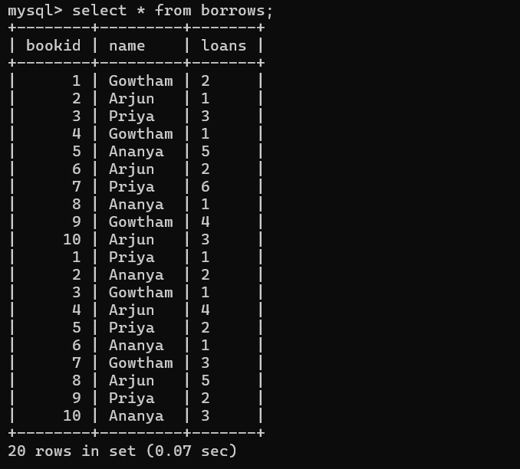

1)List all books borrowed by a specific borrower.(I take Gowtham as specific user)
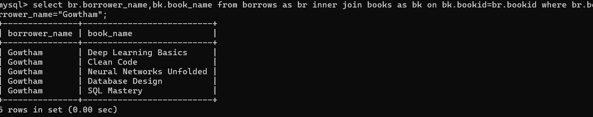
2)Find authors whose books are borrowed more than 5 times.
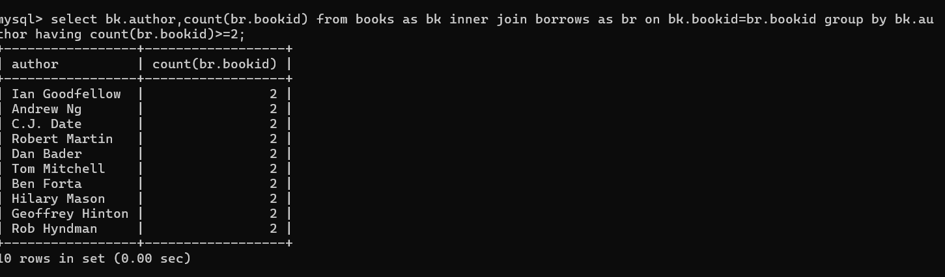
3)Count the number of books each borrower has borrowed.

